Confusion matrix, without normalization

[[6 2 0 0]

[1 6 0 1]

[0 1 7 0]

[0 1 2 5]]

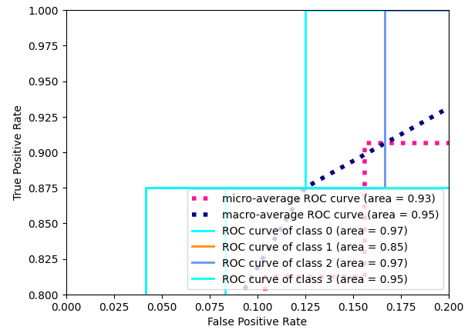



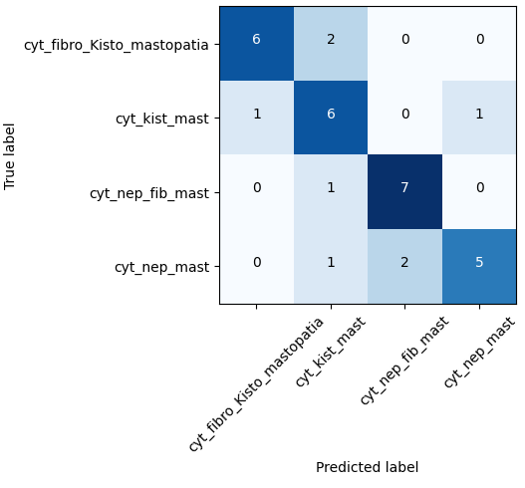

precision recall f1-score support

0 0.86 0.75 0.80 8

1 0.60 0.75 0.67 8

2 0.78 0.88 0.82 8

3 0.83 0.62 0.71 8

accuracy 0.75 32

macro avg 0.77 0.75 0.75 32

weighted avg 0.77 0.75 0.75 32

https://towardsdatascience.com/implementing-alexnet-cnn-architecture-using-tensorflow-2-0-and-keras-2113e090ad98